ADTA 5750: Applied Natural Language Processing
Thuan L Nguyen, PhD
Final Project

Conversational AI System: Testing and Deployment
Team: CarToGo (group 6)
Team Members:
- Sonali Sabnam
- Sheba Rani Paladugu
- Rinal Shah
- Rejesh Anne
- Tao Xiong
- Akhila Uppula

PART V: Conversational AI System: Testing and Deployment

The development of the chatbot for CarToGo – Car Rental Service is developed on GCP DialogFlow CX platform. The testing of the system is carried out using the DialogFlow messenger tool on GCP by providing various dialogues as below, to test all the flows and functionalities of the chatbot.

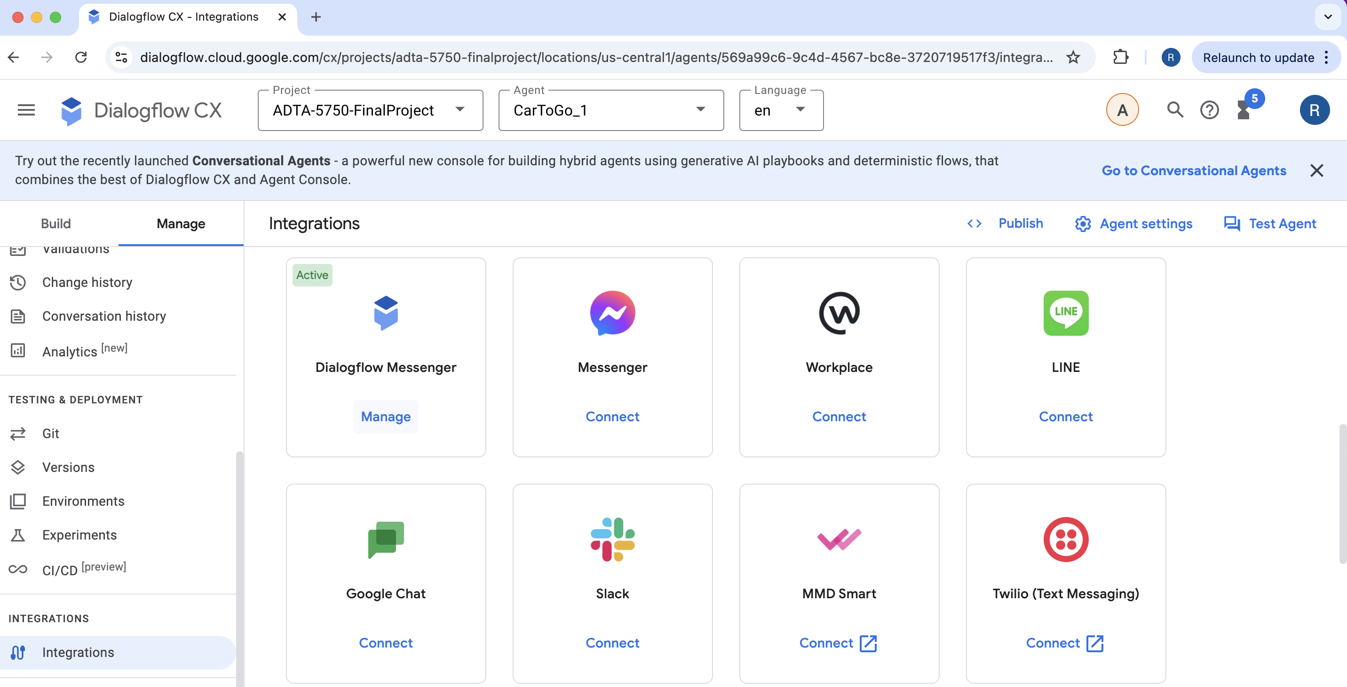

Steps to perform testing –

- Default Start Flow

- When user send a message ‘Hi’ to the system, the chatbot will reply with a welcome message as below and provides the option to book a car

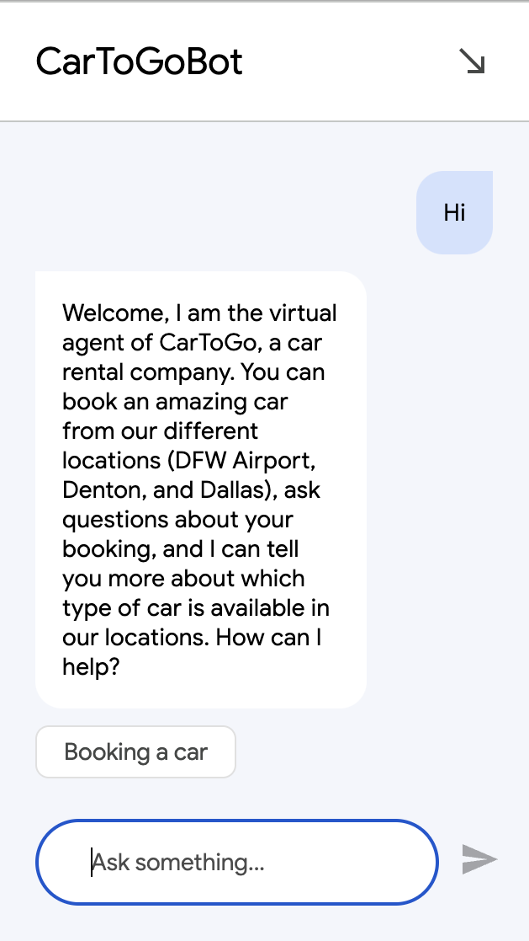

- Booking Flow

- When user selects ‘Booking a car’ option, The chatbot will ask next question to choose the car type as below –

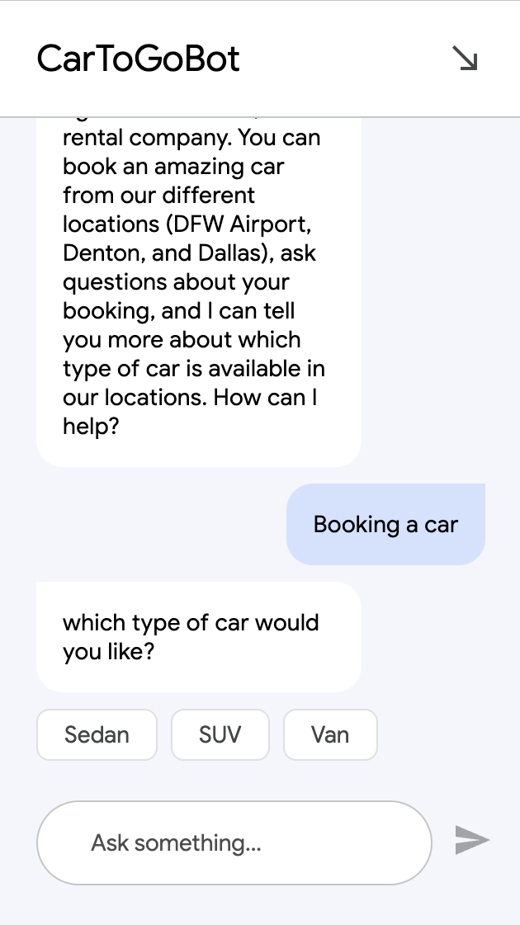

- Once the user selects the car type, the bot will ask about the desired size of the car as below –

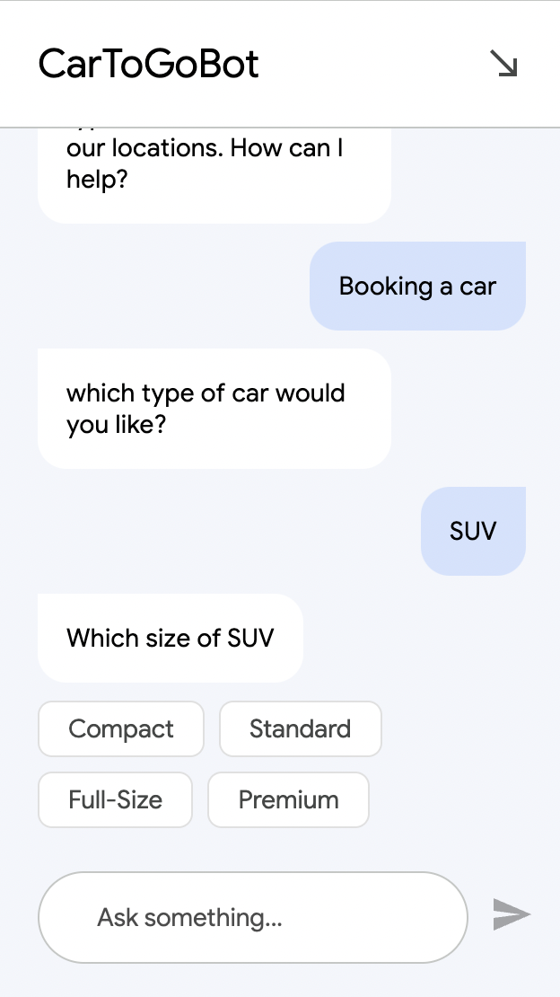

- The user provides the car size which may be one of the Standard, Compact, Full-size, Premium.

- The bot will next ask about the seaters to know the number of passengers and user can provide the number as shown in image.

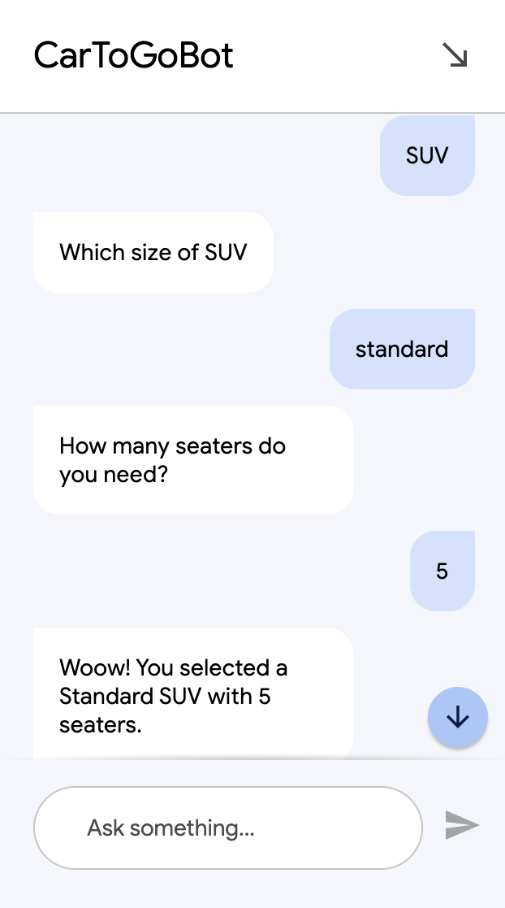 or 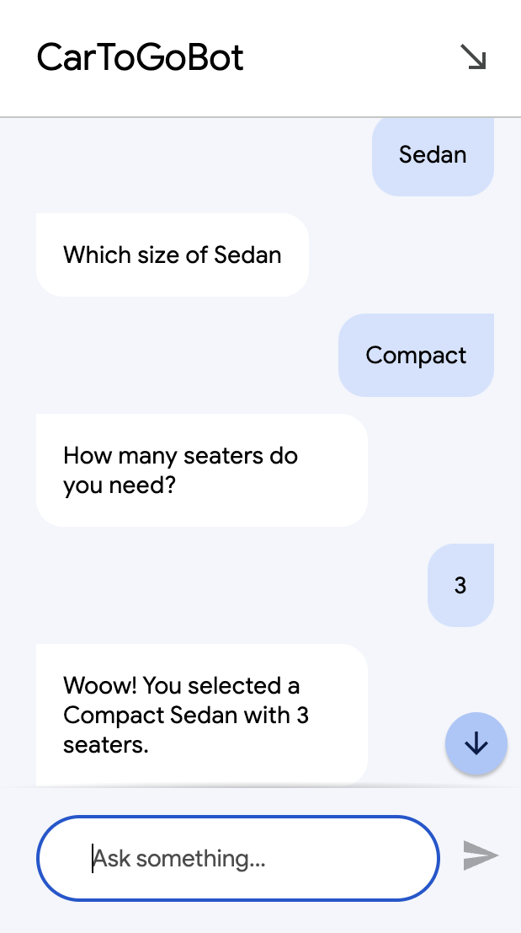

- Once the user specifies the number of seater, The system will reply with above message with selected car type and number of seater.

- If user provides inappropriate number for the selected car, he will get below message from bot –

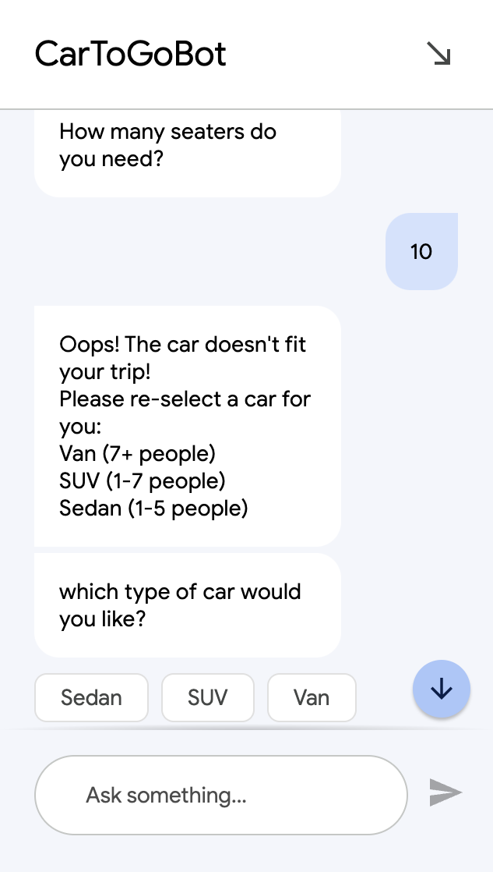 or 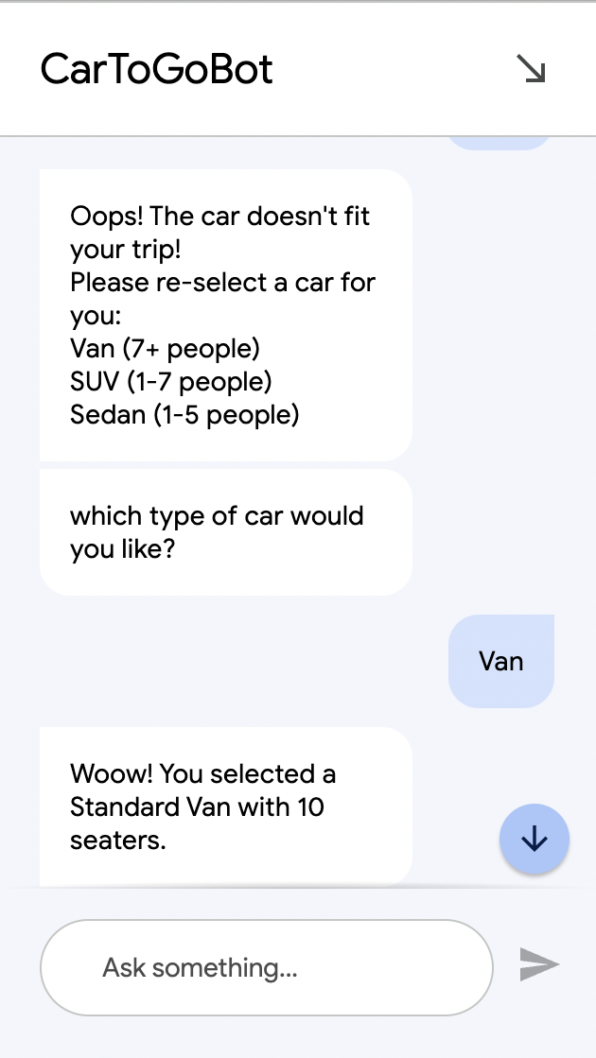

- The bot will then ask the pickup location, providing 3 pickup locations to choose from.

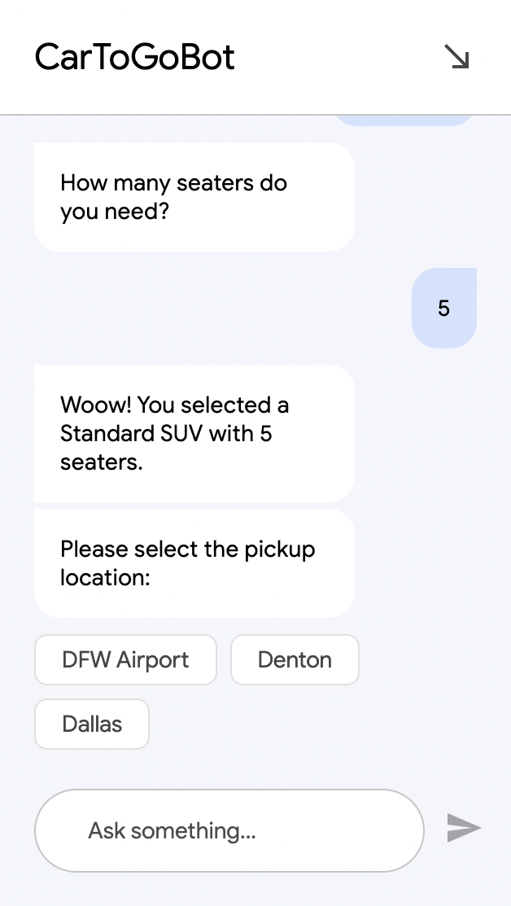 or 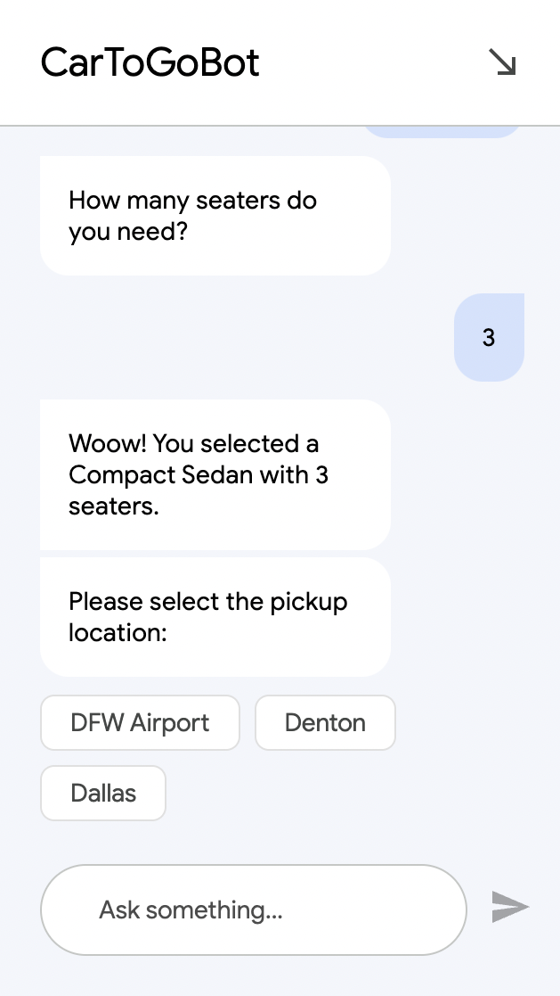

- User can select his pickup location from given options.

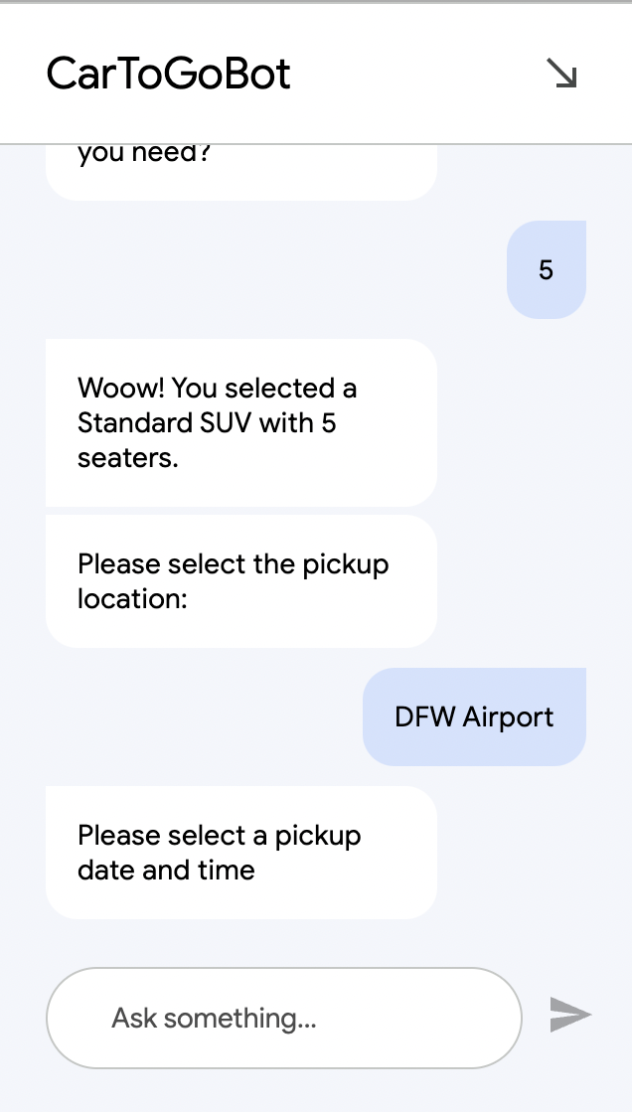

- Next, bot will ask the pickup date and time. User can provide pickup information.

- Then the bot will ask about the drop off location.

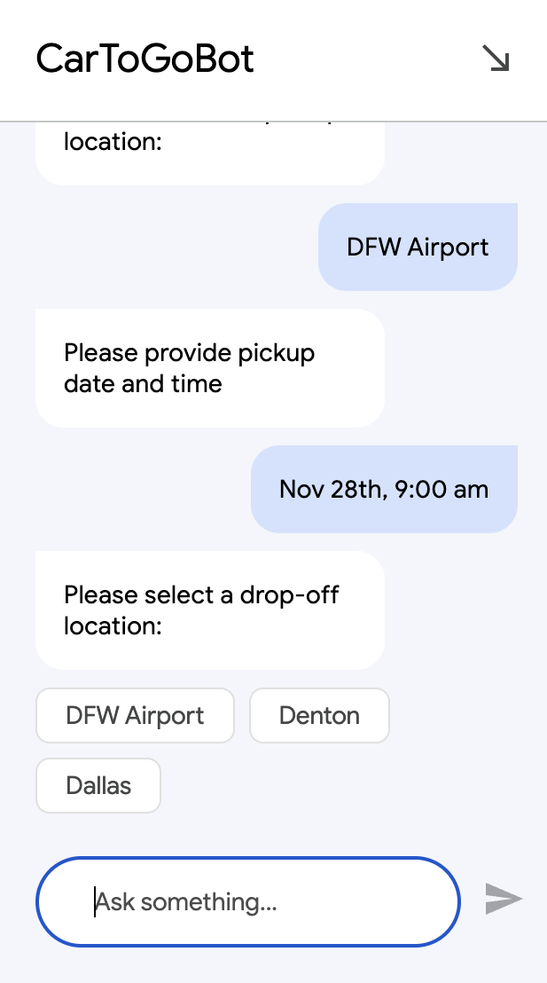

- When user selects the drop off location from given options, the bot will ask about drop off date and time. User can provide drop off information.

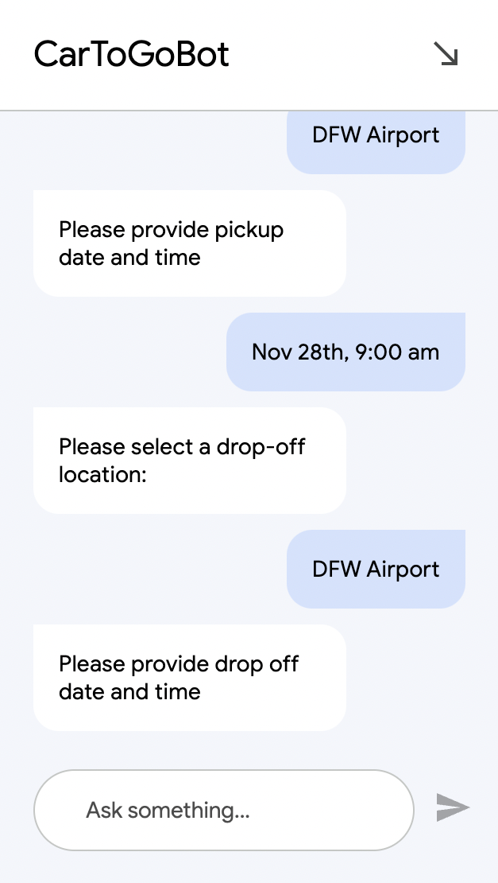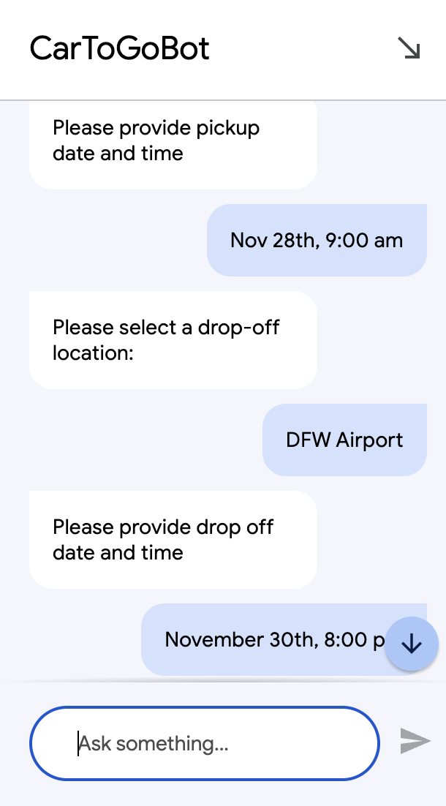

- If user provides inappropriate details, the bot will again ask to get the correct information.

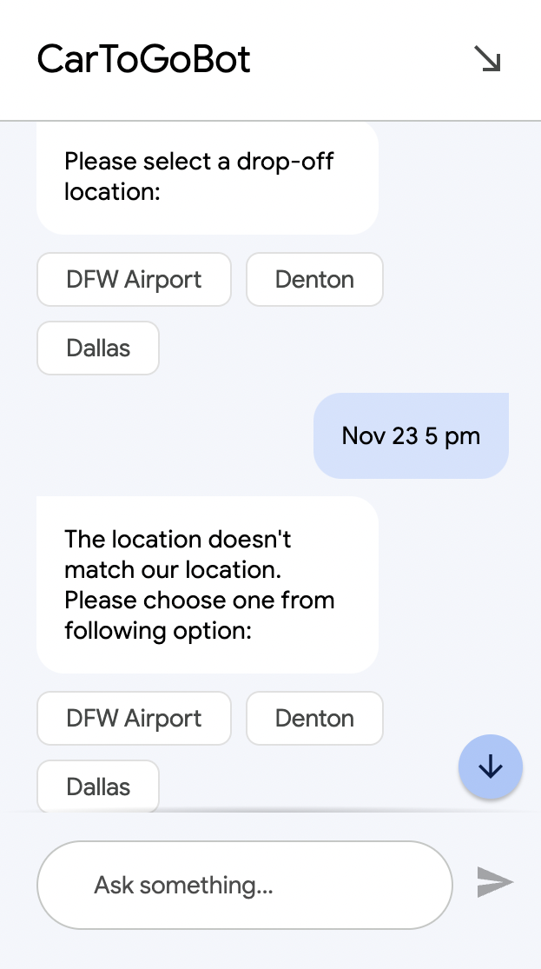

- Here, the user can provide same or different pickup and drop off locations.

- Once the pickup and drop off information is provided, the bot will respond with confirmation message including all the details the user has provided, It will ask for Confirm, Cancel or Swap the booking–
User can select any of the option.

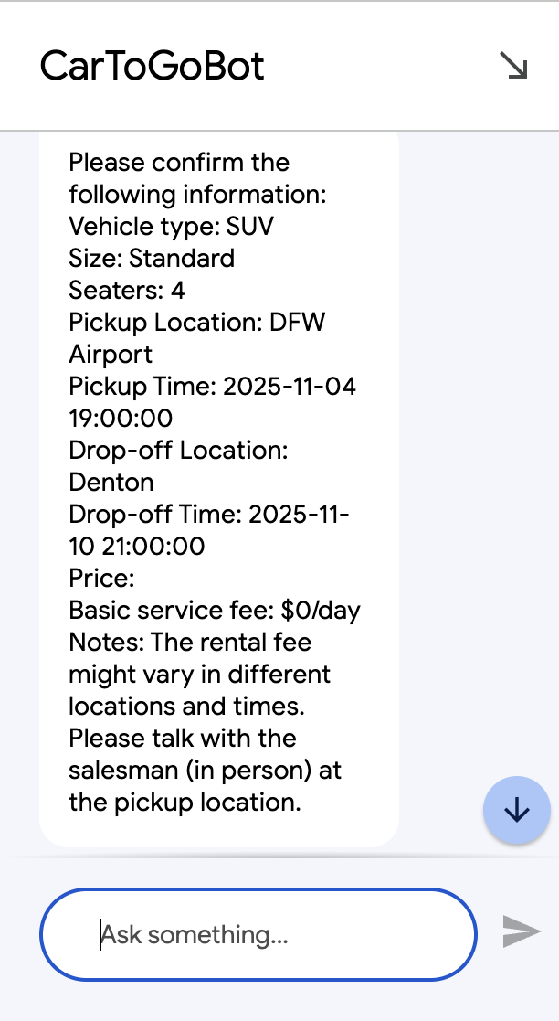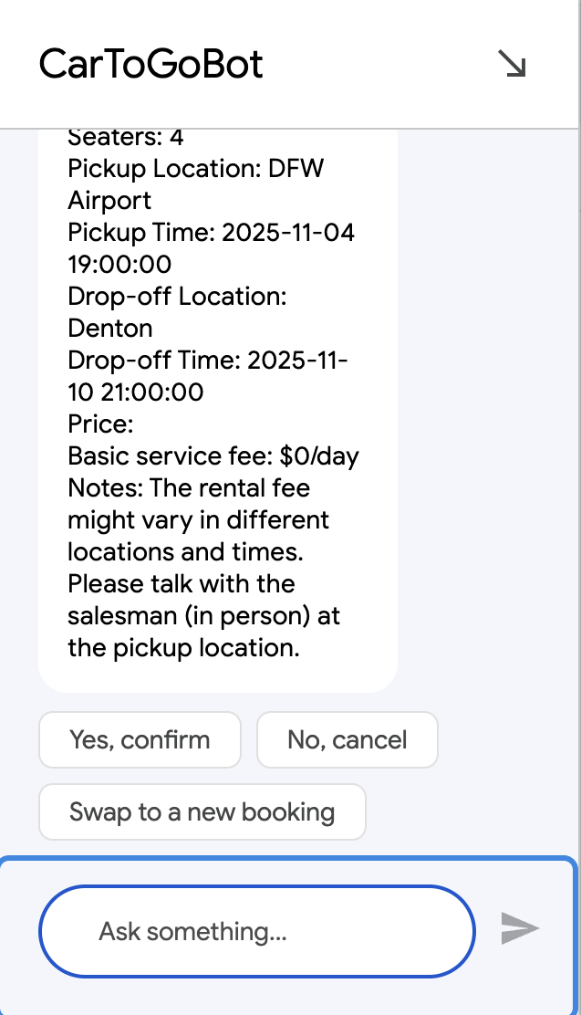

- Cancel Flow –

- If the customer selects ‘No, Cancel’ option, the bot will ask one more time to confirm cancel booking or swap the booking.

- When user says ‘Yes’, the bot will respond with the message that ‘Your booking has been cancelled! Have a good day!’

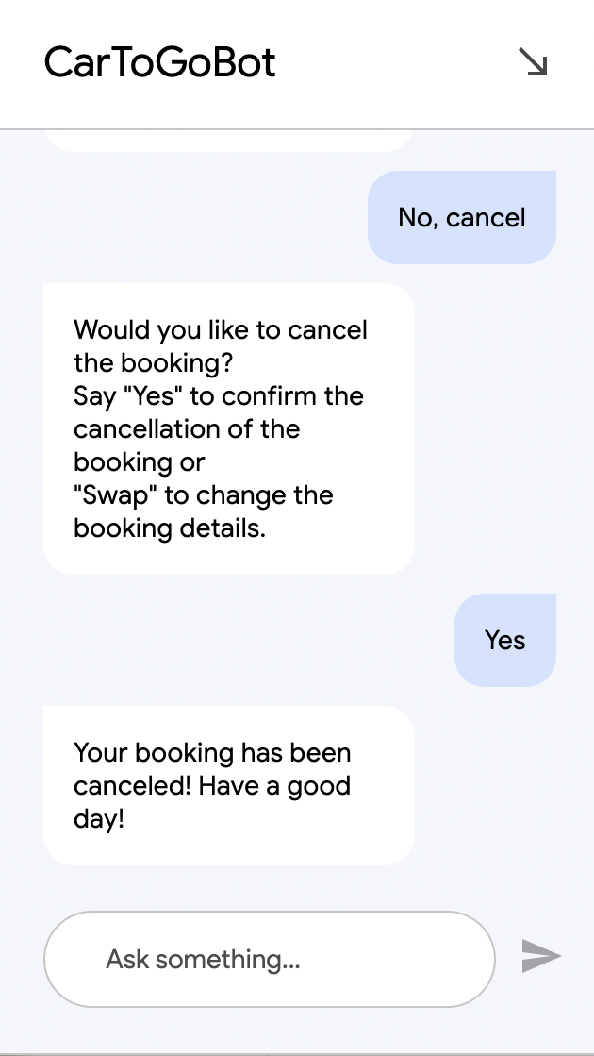

- Confirm Flow –

- If user selects ‘Yes, confirm’, The bot will proceed to gather customer details – first name, last name, phone number and email address.

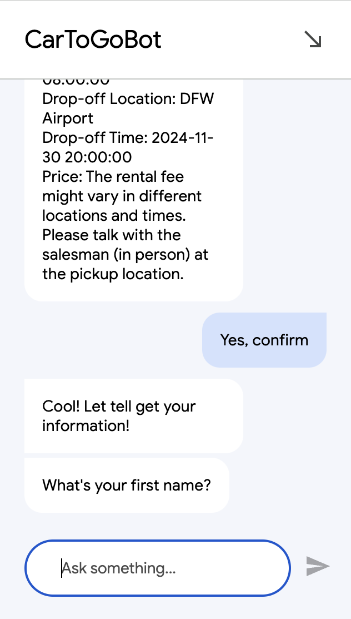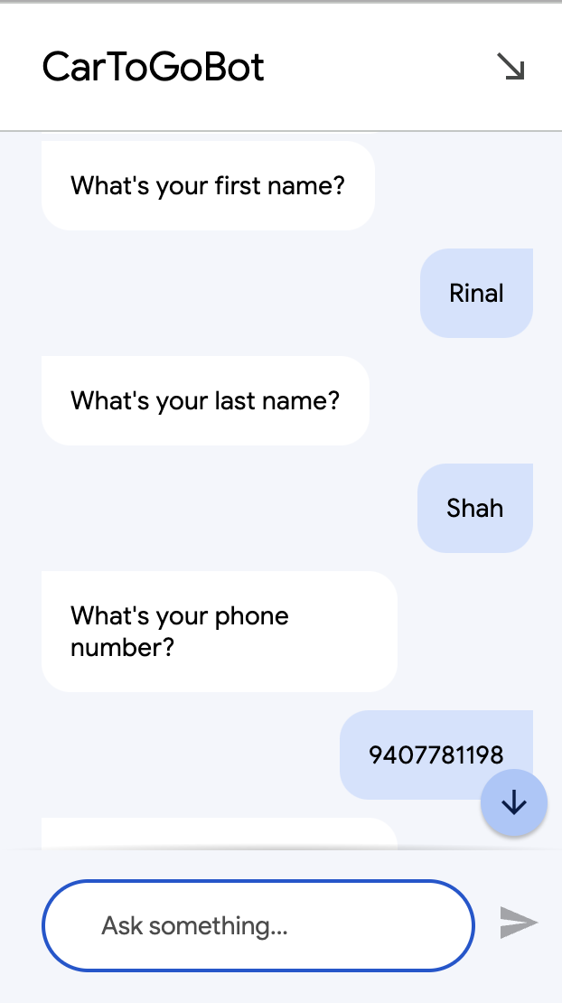

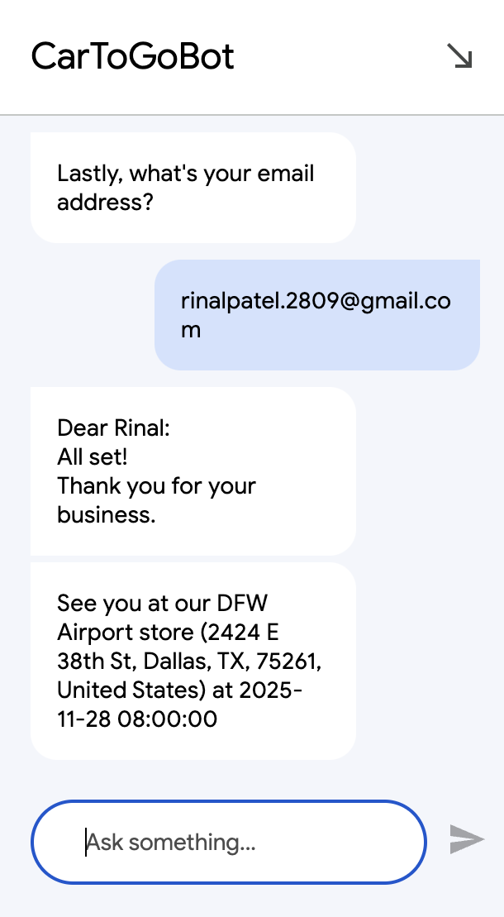

- Once, the customer provides personal details, The bot will respond with confirmation message which has pickup address and pickup datetime.

- Swap Flow –

- If the user selects ‘Swap to a new booking’, the bot will ask customer to provide ‘booking’ command and then ask questions right from the beginning to know the choice of user about the new car. It will ask the car type, car size and seater to finalise the new rental car for customer. Then the bot will ask for pickup and drop-off details and confirm the new booking.

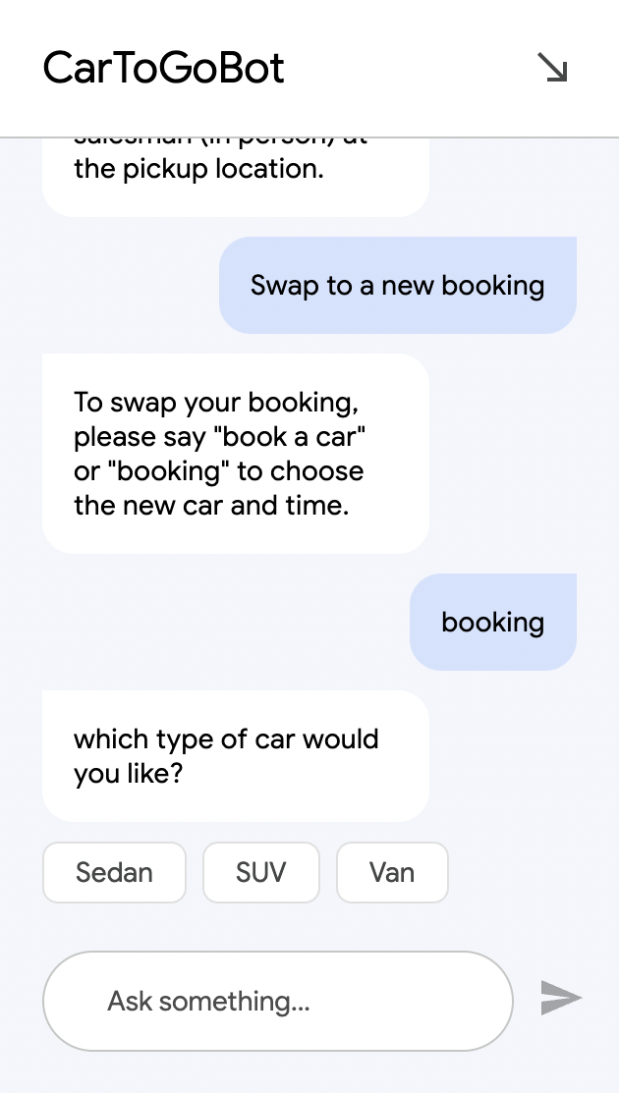

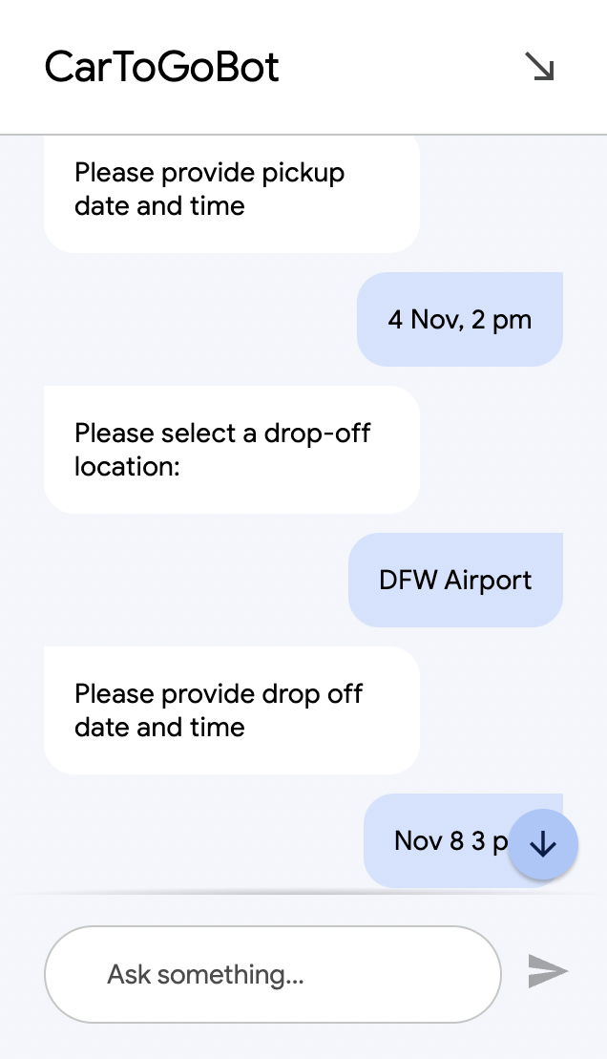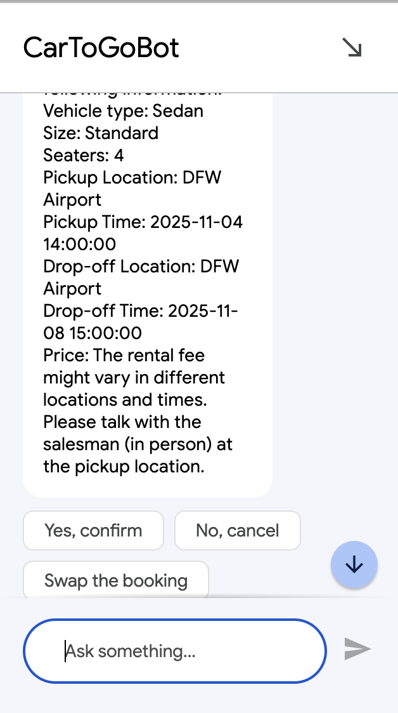

Test Cases –

In the DialogFlow CX, We can create various test cases to test our system.
We have created few test cases to test the different scenarios in the system and all the cases passed in testing as shown below -
